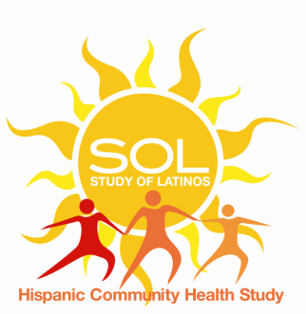

Consortium Form

Date of submission:
Consortium Name:
Short Consortium Name or Acronym:

Name of Investigator submitting application:
Institution:
Email:
The HCHS/SOL parent study PI or co-PI sponsoring this application is/are:
Brief synopsis of consortium (should not exceed 100 words):
1) Consortium leadership:
 | Principal Investigator | Co-Principal Investigator | Co-Principal Investigator
Name
Email
Phone
Institution

2) Other Cohorts/Institutions in the Consortium (indicate if agreed or pending):
3) Consortium website:
4) We agree to follow HCHS/SOL policies and procedures including that the consortium manuscripts proposals and draft manuscripts that include HCHS/SOL will go through the HCHS/SOL review process using the study website portal on the HCHS/SOL format. I agree: Yes No

Submit this form either with the
- Ancillary Study proposal to HCHSAncillary@unc.edu
or
- Manuscript proposal to the Publications Committee using HCHS/SOL website.

